**PYTHON BASIC PROJECT**

**1. PASSWORD GENERATOR**

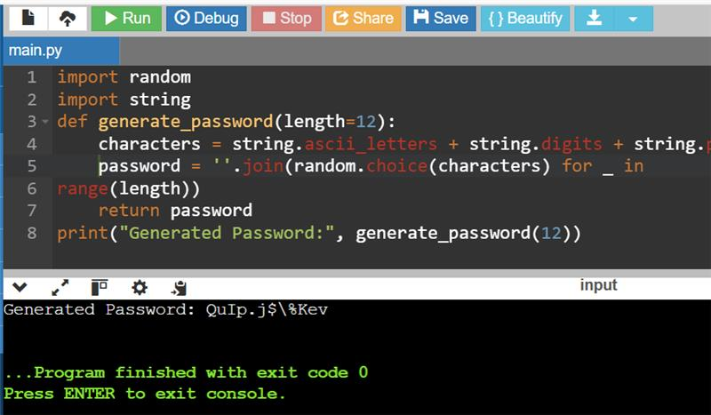

**2. TO-DO LIST**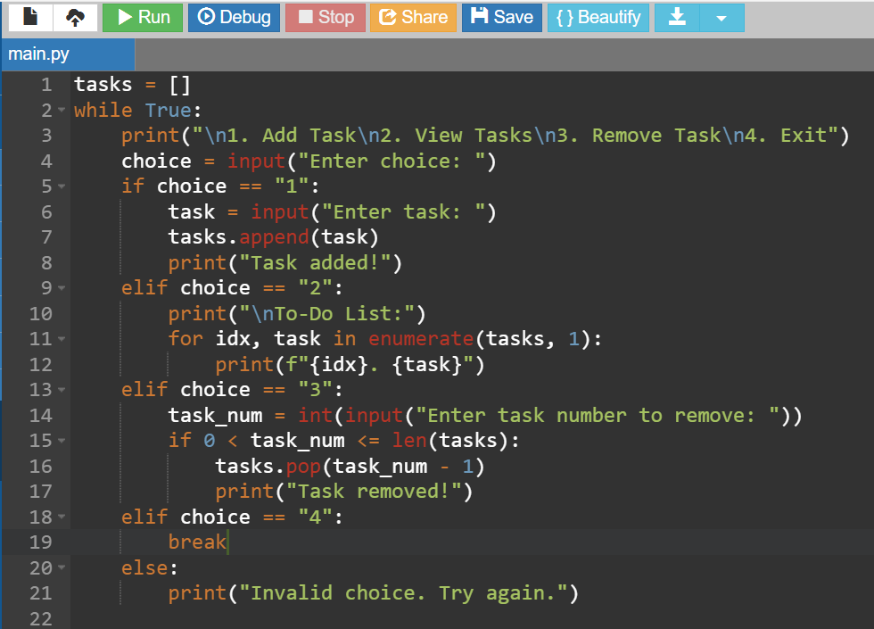

**Output:**

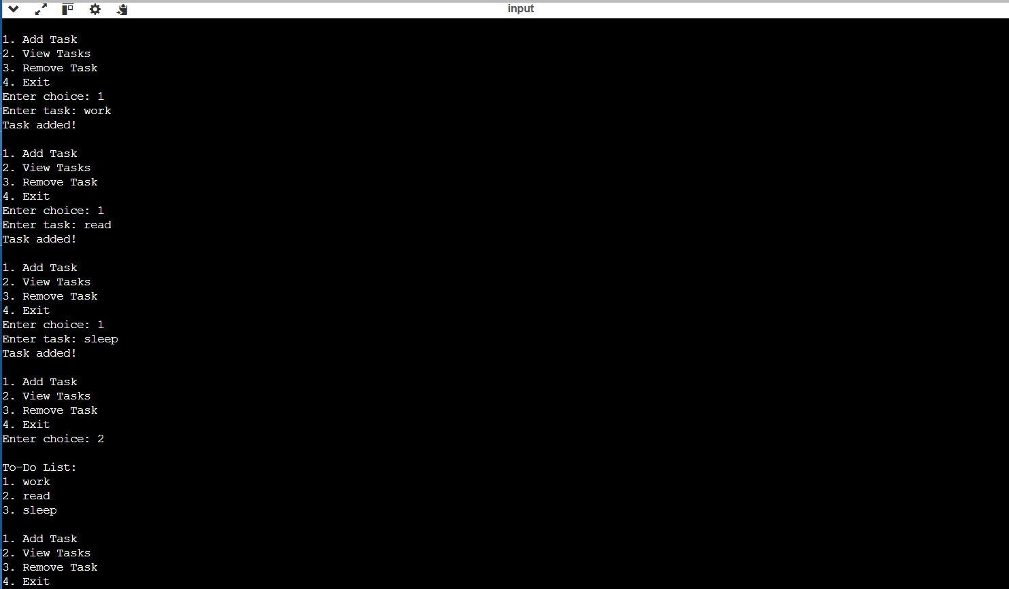

**WEATHER APP (API Based):**

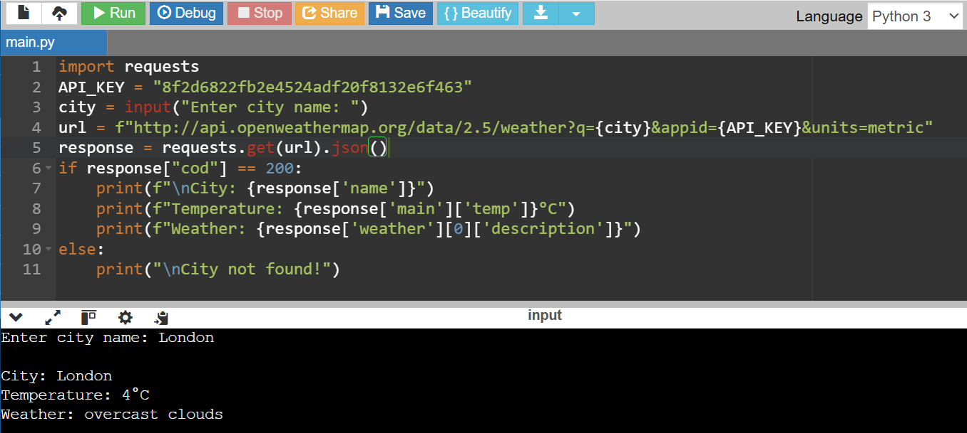

**NUMBER GUESSING GAME:**

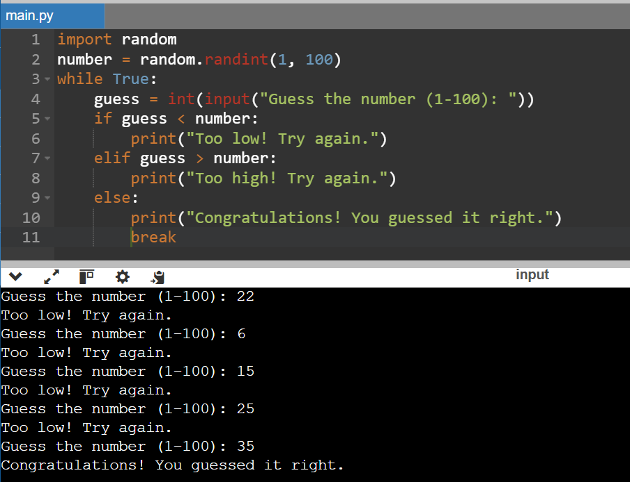

**1. QR CODE GENERATOR:**

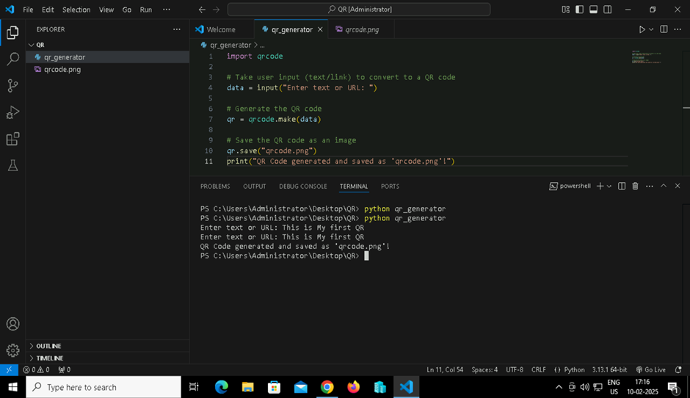

Output:

